**Tableau interactive dashboard:**

[Tableau dashboard: Actual vs Predicted Views](https://public.tableau.com/app/profile/ahmed.ali2746/viz/CSE6242Dashboard/Dashboard1?publish=yes)

**Demo Videos:**

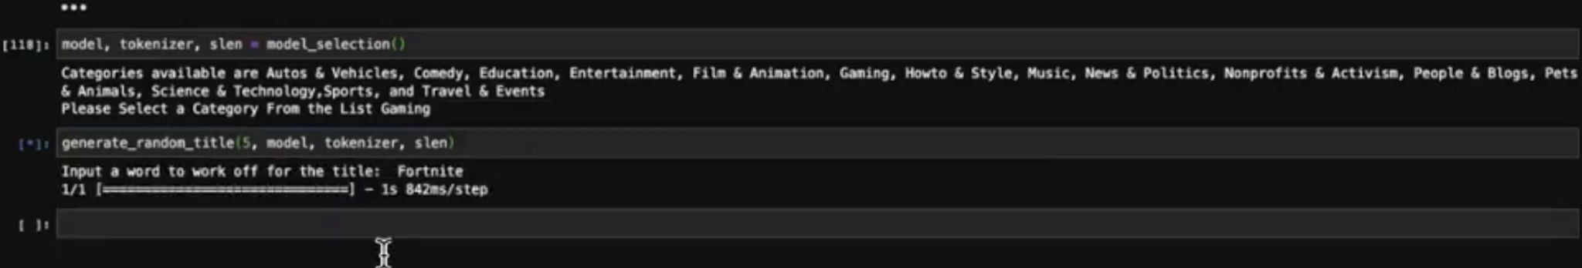

**Suggestive Title Maker Demo**

https://www.youtube.com/watch?v=NnDy2IOwaoM

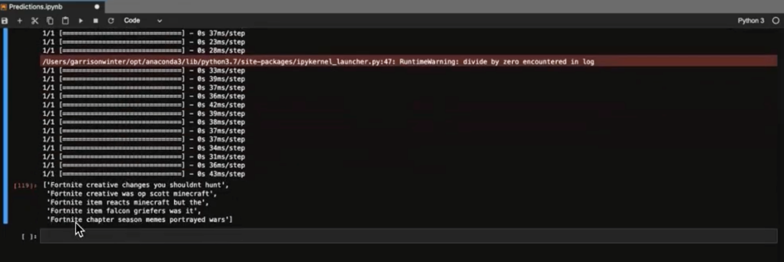

**Tagging Network Recommendation**

https://youtu.be/UdNvKBD7Sgw

